1)Load employeee dataset order by rating desc and by emp_name asc order then limit it by 5 as we want employees with highest rating then generate id and name

2)Used filter to find odd id employess and then ordered by salary desc and then limit by 3 as we want top 3 salary of employees

3)As we want employee with max expenses join both relation and then group by emp_id,emp_name and then find the sum of expenses and then order by desc limit 1 to get maximum

4)Just did inner join and then displayed the output

5) I did left outer join and then used is null for filtering empty records and generating id,emp_name;

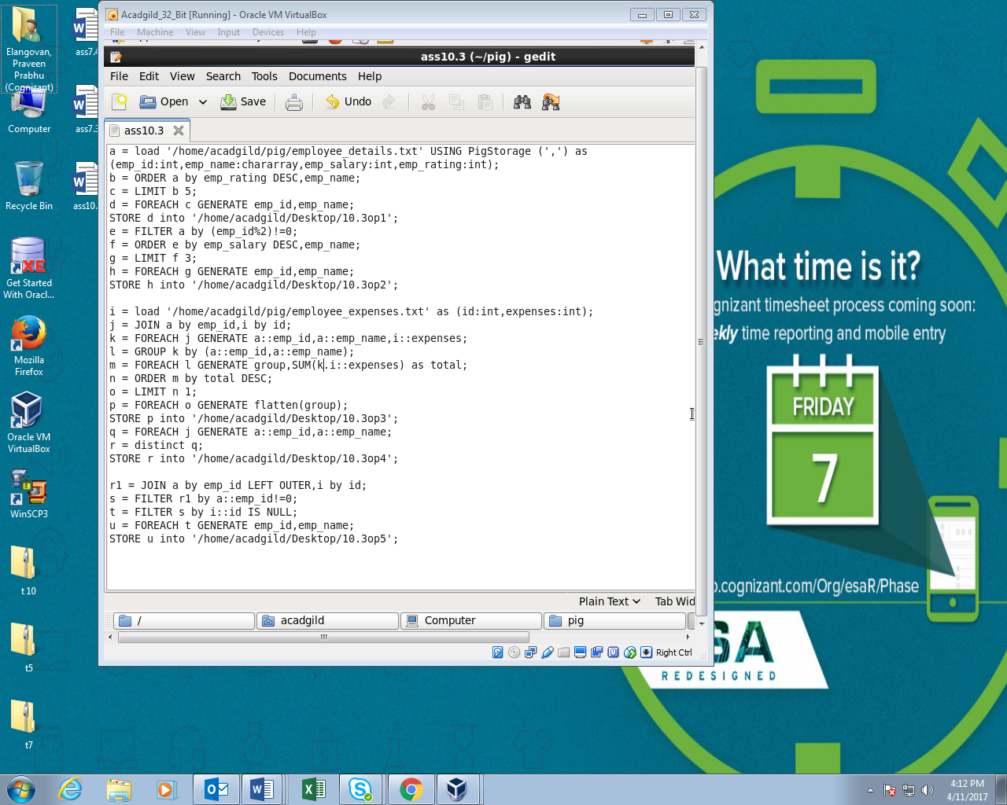

Running Pig script:

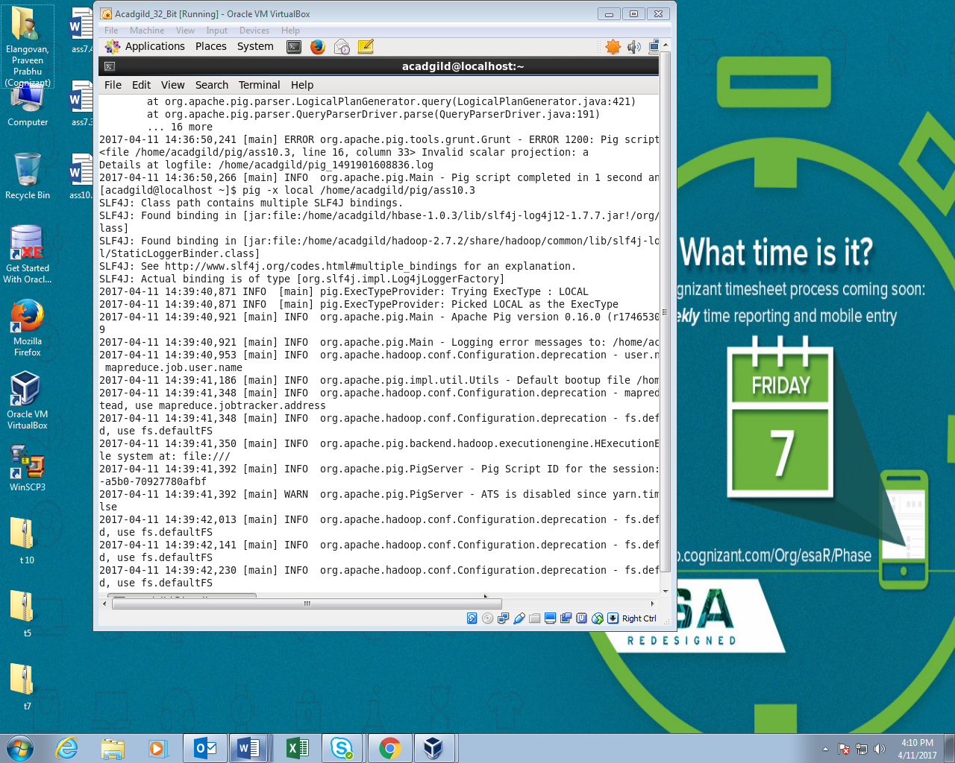

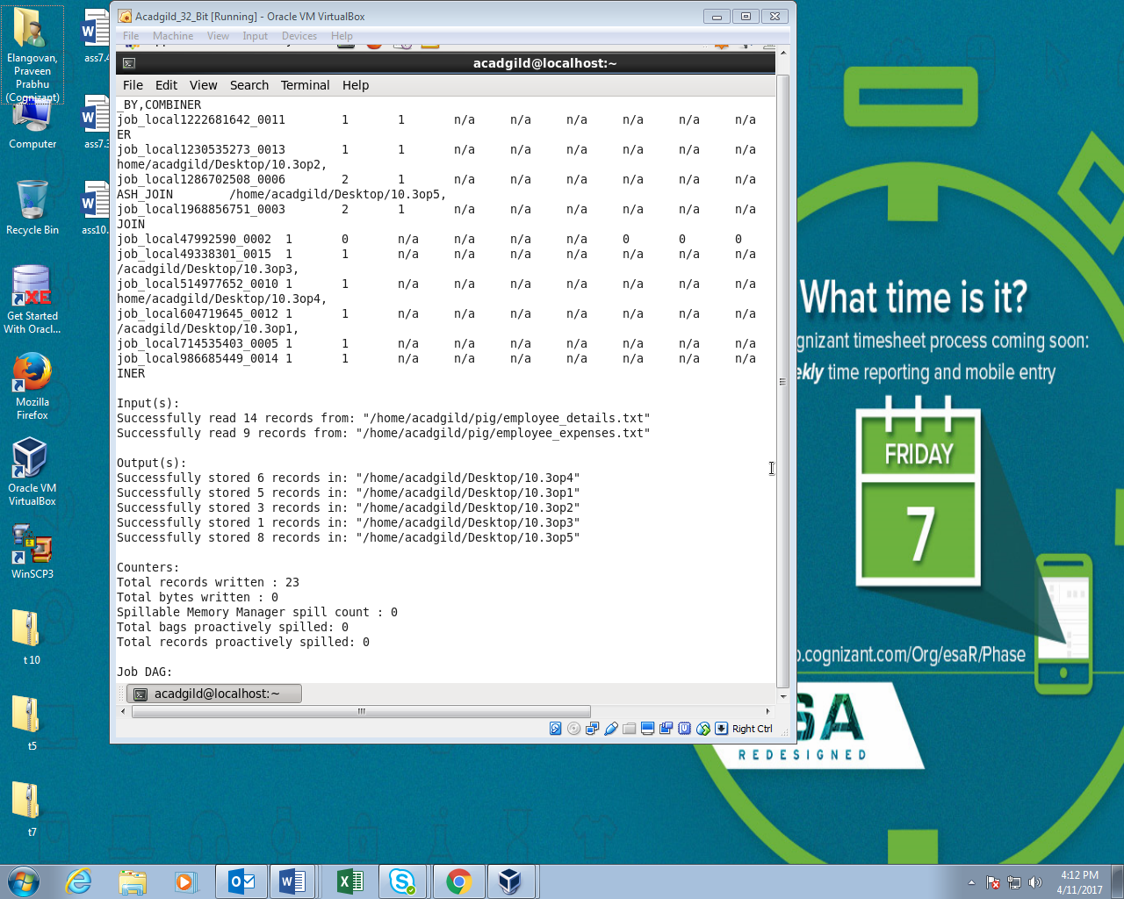

Output:

